Reading, Writing, and Poetry Workshop (Purple Heart)
Wednesday July 17th 7-8:30 PM
Free Library of NorthamptonTownship….Richboro, PA

Join multiple award winning author/educator (20 books) Tom Palumbo on Wednesday July 17th from 7-8:30 PM for a FREE fast paced 90 minutes of creative activities for teaching reading, writing, and poetry. A ten-page take home booklet of lessons, games, puzzles, and critical thinking challenges will be introduced and demonstrated. This workshop is perfect for parents, teachers, educators, college students, and those looking for an evening of mental stimulation.

In addition to the work booklet, any participant bringing in a bag of clothes for Purple Heart will receive a CD loaded with over 30 PowerPoints, book talks, educational games, enriching lessons, and short and long term classroom and at home projects. There is room for 25 participants in this workshop. The workshop will be held in the library’s conference room next to the computer laboratory.

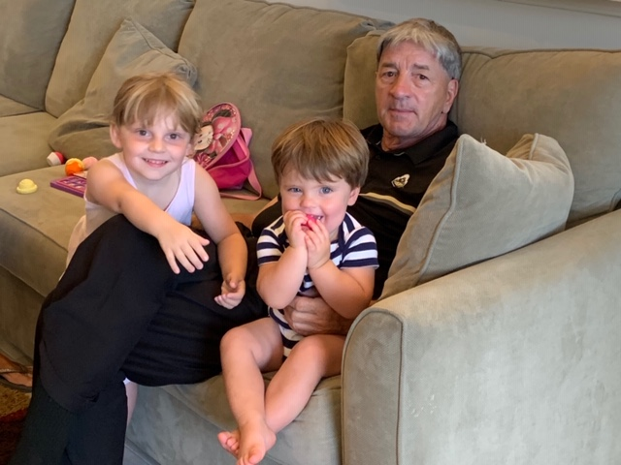

Front Desk And Library Website Sign-up Is Available!

