REPORT FOR CHAT ACTION

*Sign in to ORIGIN – Complete a Survey – View the Results in Various Ways – Site Map*

December 27, 2020

Bruce Schuman, [bruceschuman@cox.net](mailto:bruceschuman@cox.net), Santa Barbara CA, http://origin.org

This report introduces the survey (or “polling”) framework on ORIGIN, as we have developed it to support the activities of ChatAction. Please take a minute to read through this report. You will find your experience much simpler if you take a minute to get the lay of the land.

ORIGIN is a secure (“signed in”) database networking system for people who want to support the emerging new paradigm, and this certainly includes people involved with Humanity Rising and ChatPeople/ChatAction.

To begin, please go to <http://origin.org> and sign in with your email address and your password. If you don’t have an account, you can create one in a couple of minutes. Click the **Join Us** button to join.

Put your email address and password into the boxes and click the SIGN IN button.

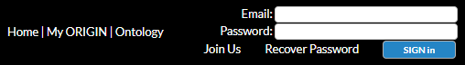

To work with the polling framework, click on the POLLING link, which will take you to our “My skillset” survey – which is our first crack at organizing this community for events we might create.



The survey is briefly introduced. Respond to one question at a time.

To view the results of the survey to date, click the “respondents” link shown below underlined in red. This shows you all results of the survey, which you can search and sort in various ways.

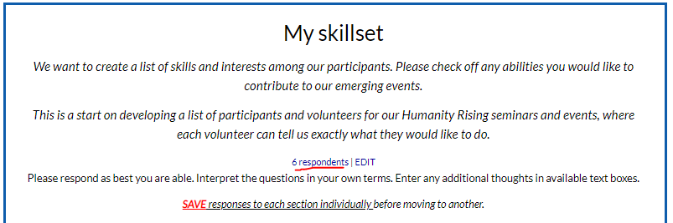

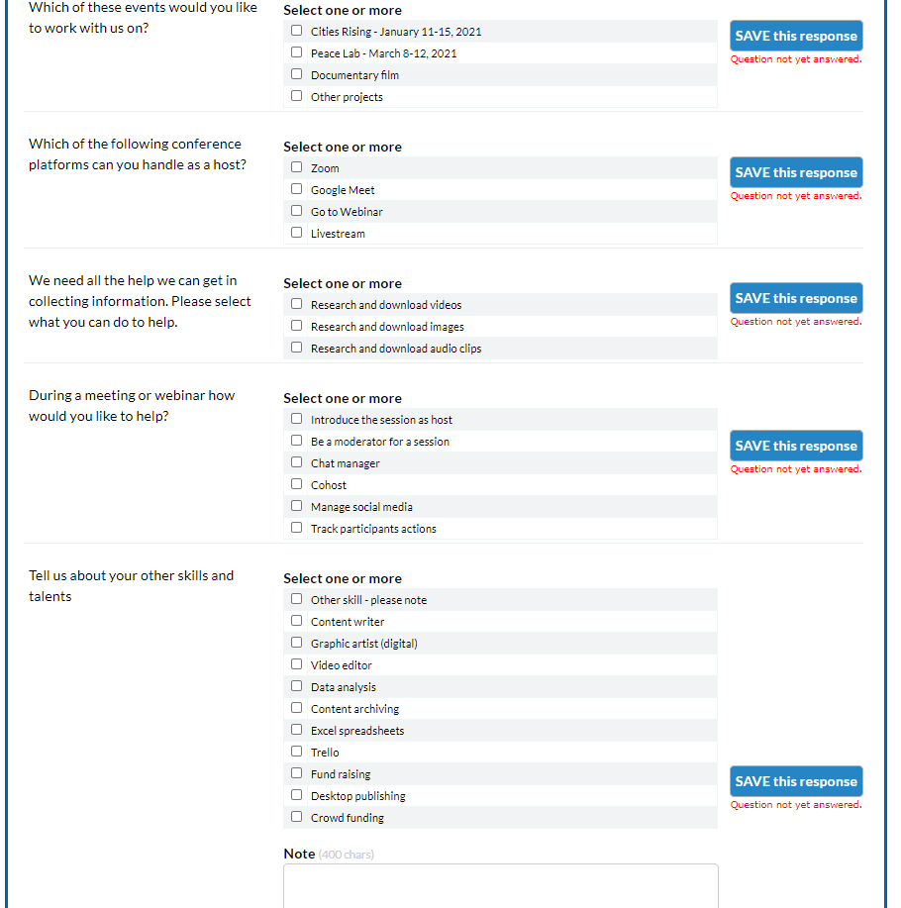

Please complete this poll if you have not already done so. It’s very fast and simple, and you can do it in just a few minutes or less. I just completed it in about one minute on a test account.

Here is a sample poll response, from Shannon McArthur, which just happened to be at the top of the list, followed by an imaginary test account for Adam Andevski.

For now, the title of the poll is “My skillset”. We can change it to anything we like when we are ready to broadcast it to a large audience. There are several ways you can search and organize these results, including the choice to search by “option” – for example, how many people said they can host Zoom – and who are they? Click “SELECT display” to see alternatives.

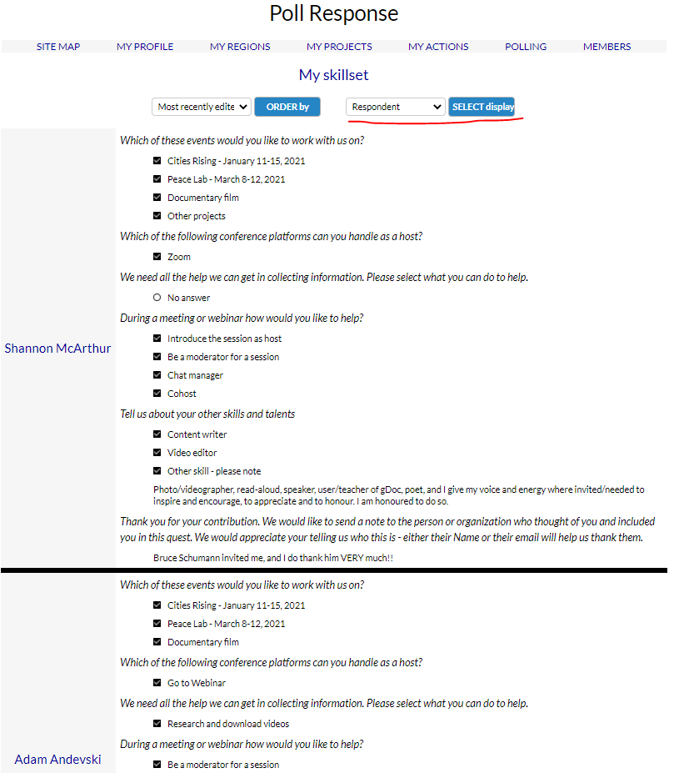

For now, there are three optional ways to view the survey results, which are

* Respondent – the raw list of everybody who has responded with all their answers, which is the format shown above
* Question – which will enable you to pick any question and see all the answers and who entered that answer (this feature not installed as of this moment)
* Option – an important feature which enables you to view who selected which option for which question.

Select “Option” and this is what you will see for the My Skillset survey.

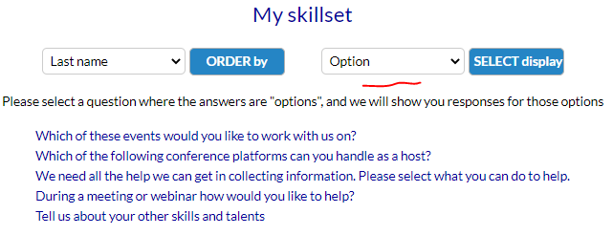

This is an important feature for conference organizers. The My Skillset survey is organized as a long series of “options” (in this case, checkboxes), and we need to know who clicked what option.

Pick the question you are interested in, and you will see all the responses.

The “Which of the follow conference platforms…” question returns this result

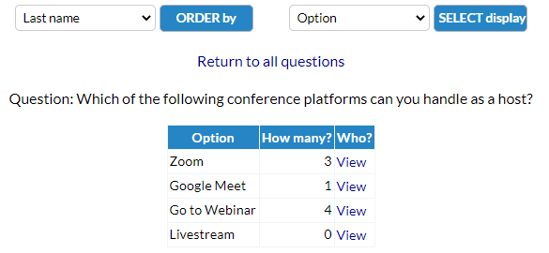

This display shows how many people clicked each option under that question, with a link to see who they are.

Click the “View” link for the Zoom option, and you will see the list of people who can or want to host Zoom meetings. Click “Return to all questions” to go back to the complete list of questions with options.

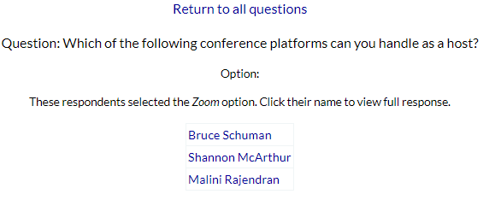

Click the Shannon McArthur link, and you go to Shannon’s complete response, with no other participants listed.

Click on Shannon’s name in the left hand column of her response and you go to her profile, which includes everything we’ve managed to collect about Shannon, including the complete lists of polls she has completed.

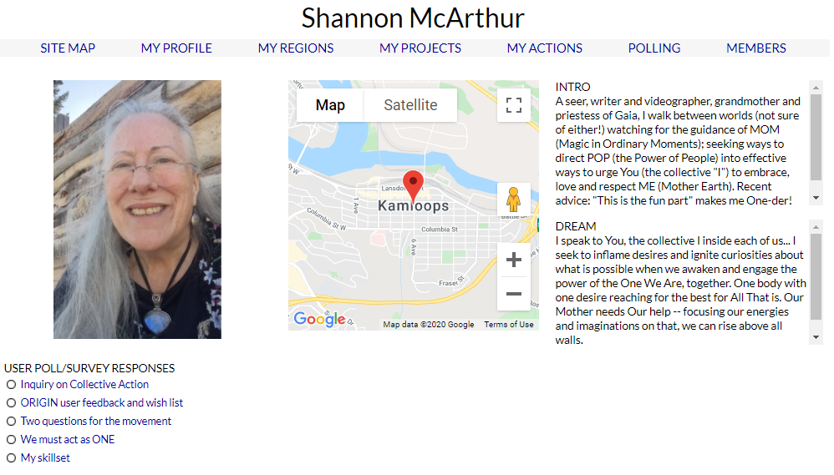

We’ll get more stuff on this page soon. For right now, you can click on any of these survey responses and see Shannon’s complete response to that particular survey.

On Site Map and Navigation, for right now, the most important link on the site is My ORIGIN

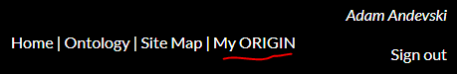

This link takes you to the last page you clicked on this menu – which for “Adam Andevski” happens to be his “My Profile” page.

